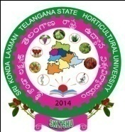

SRI KONDA LAXMAN TELANGANA STATE HORTICULTURAL UNIVERSITY
Administrative Office, Rajendranagar, Hyderabad – 500 030
Notification for Admission into
M.Sc. (Hort.) and Ph.D. (Hort.) Courses – 2019-20

Advt.No. 002 /PG Acad/2019 dt 25.06.2019
Applications are invited for admission into M.Sc. (Hort.) with specialization in 1) Fruit Science, 2) Vegetable Science, 3) Floriculture & Land scape Architecture, 4) Plantation, Spices, Medicinal and Aromatic Crops from candidates possessing B.Sc.(Hort.)/B.Sc.(Hons.) Horticulture and for Ph.D.(Hort.) from candidates with M.Sc. (Hort.) degree. Applications and Prospectus may be downloaded from the SKLTSHU website:www.skltshu.ac.in Last date for receipt of filled in application is 20.07.19 by 4.00 P. M.

DR. K.RAVINDER REDDY
REGISTRAR

